Audio-Text App Technical Documentation

Architecture Document

Core Architectural Philosophy
The Audio-Text application follows a modular, service-oriented architecture designed around the principle of separation of concerns. The architecture prioritizes reliability, performance, and maintainability while handling the complex interplay between audio recording, real-time processing, and AI-powered transcription services.

MVVM with Service Layer Pattern
The application employs the Model-View-ViewModel (MVVM) pattern enhanced with a comprehensive service layer. This design decision was made to isolate business logic from presentation concerns while maintaining clear data flow throughout the application. The service layer acts as an intermediary between the UI and core functionality, providing a clean abstraction that allows for easier testing and maintenance.
Each major component operates as an independent service manager that handles its specific domain. The AudioRecordingManager serves as the central coordinator for all audio-related operations, while the TranscriptionManager orchestrates the complex workflow of converting audio segments into text. This separation allows each component to evolve independently while maintaining well-defined interfaces between systems.
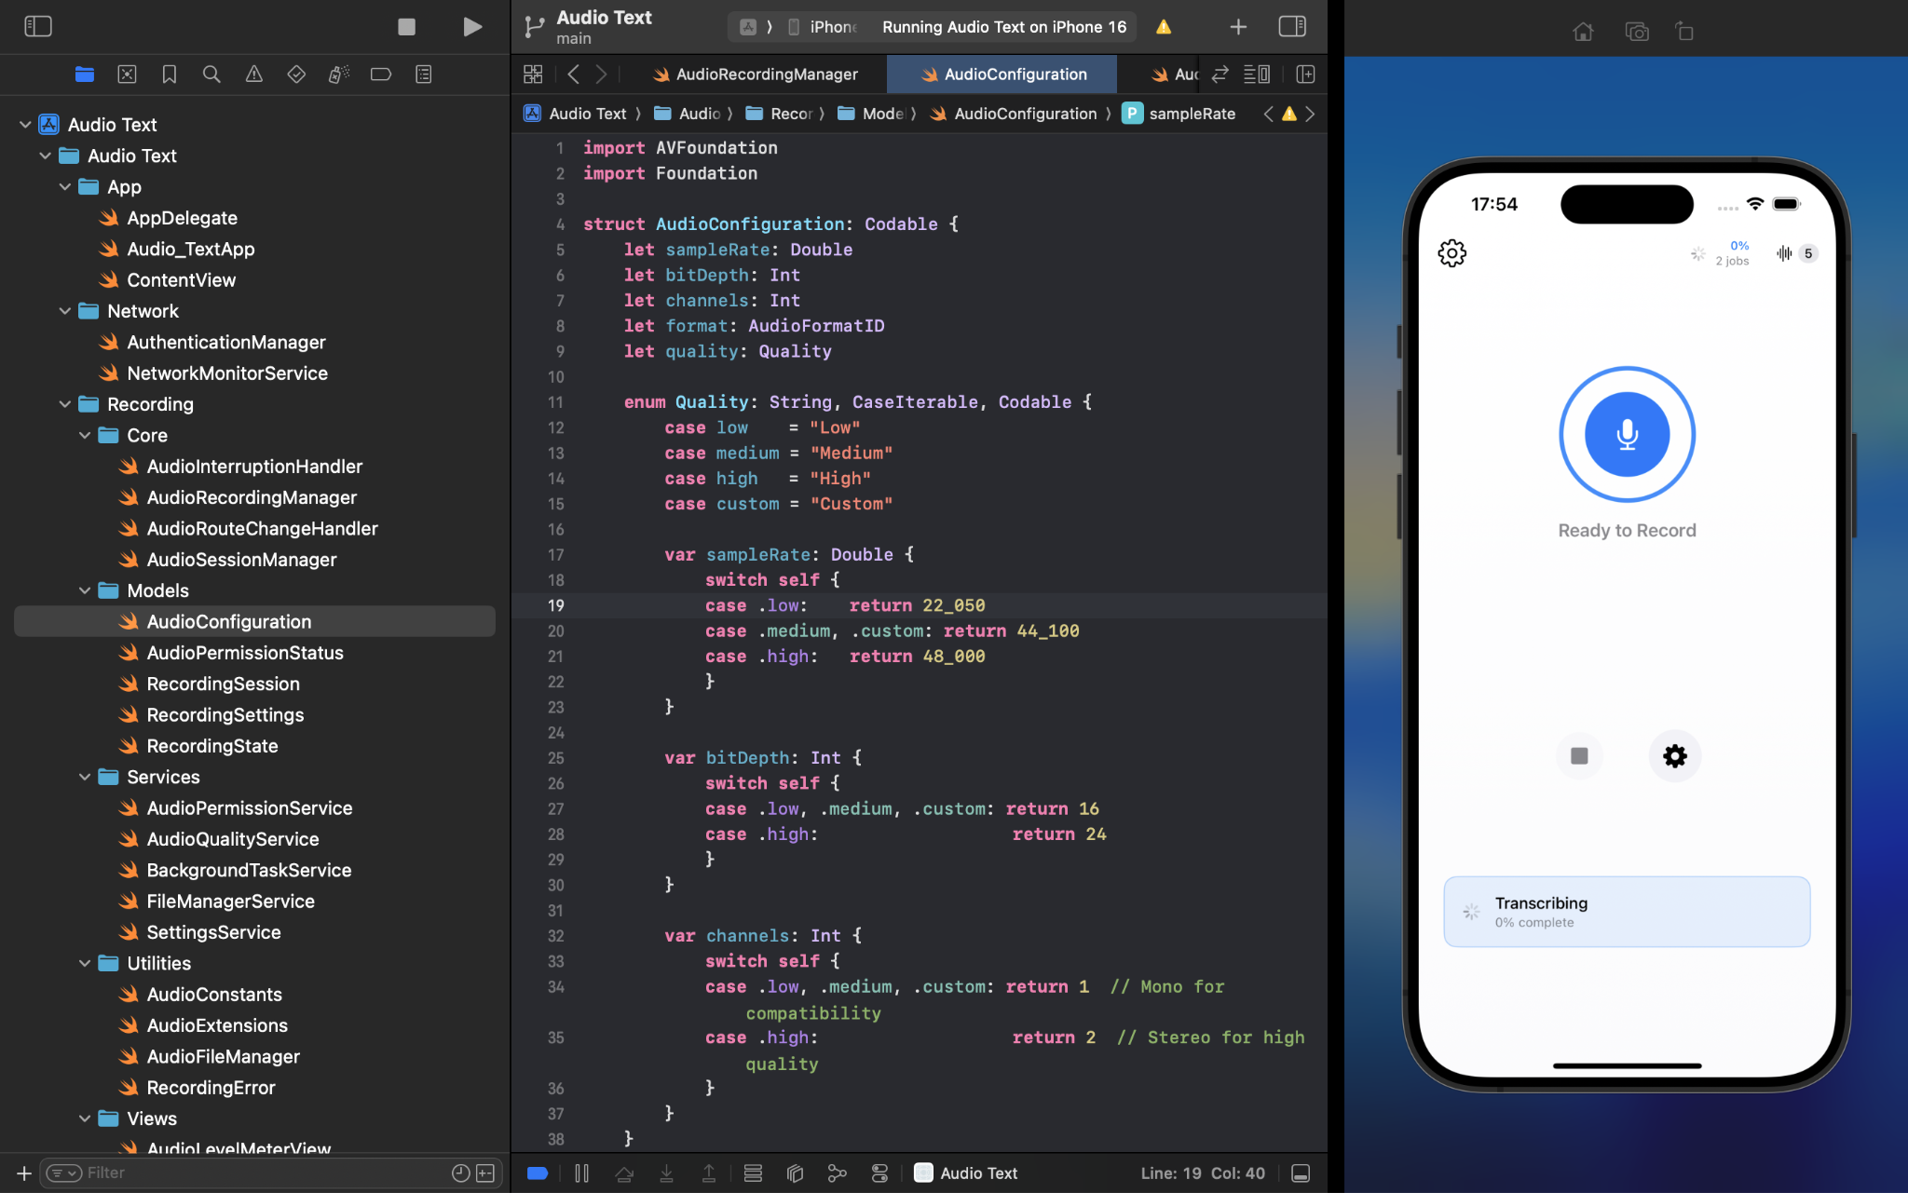

Reactive Programming with Combine
The application extensively uses Combine framework to handle asynchronous operations and maintain reactive data flow. This approach ensures that UI components automatically update when underlying data changes, creating a responsive user experience. The reactive pattern is particularly crucial for handling real-time audio processing, where multiple systems need to coordinate based on changing audio states.
Publishers and subscribers are strategically placed throughout the application to create a unified communication system. For example, when the recording state changes, multiple components react simultaneously: the UI updates its visual state, the transcription system adjusts its processing pipeline, and background task management adapts to the new context.
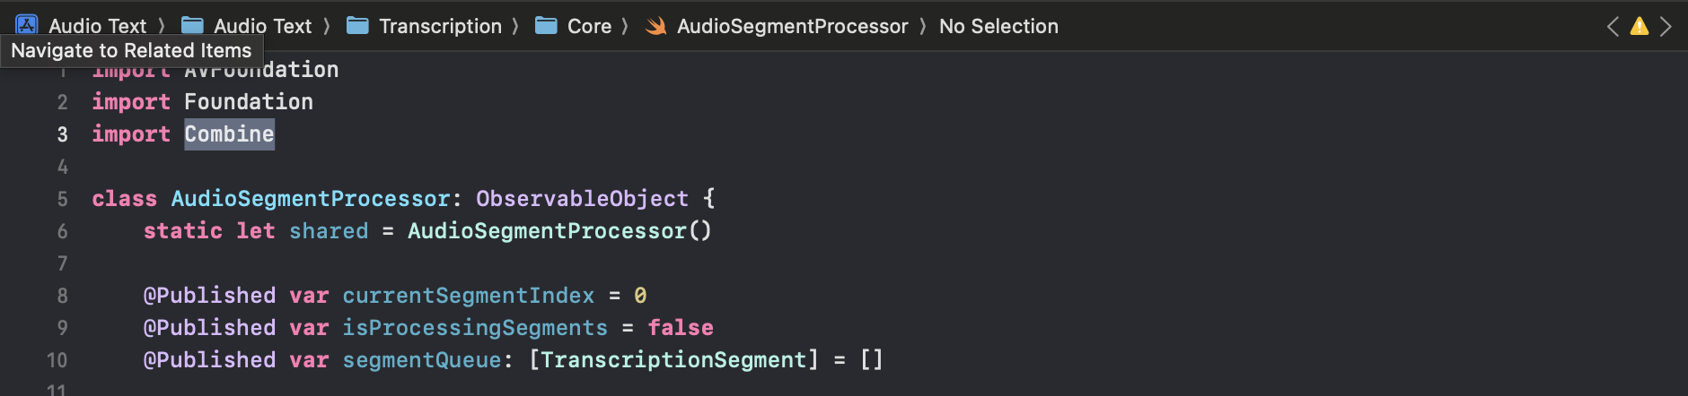

Singleton Pattern for System Services
Critical system services utilize the singleton pattern to ensure consistent state management across the application lifecycle. The AudioRecordingManager, TranscriptionManager, and related services maintain single instances that persist throughout the app's execution. This design choice was made to prevent resource conflicts and ensure that audio sessions and transcription jobs maintain their state even during view controller transitions.
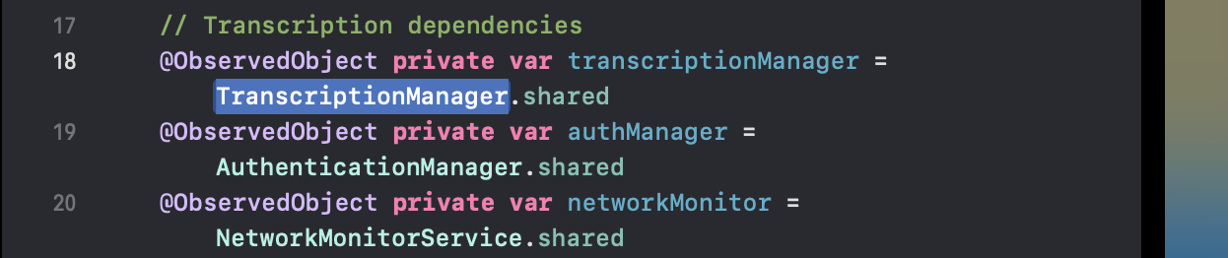
While singletons can introduce tight coupling, this architecture mitigates the issue through well-defined protocols and dependency injection patterns. Each singleton exposes its functionality through published properties and notification centers, allowing components to remain loosely coupled while benefiting from centralized state management.

Error Handling and Recovery
The architecture implements a comprehensive error handling strategy that distinguishes between recoverable and non-recoverable failures. Each service layer includes fallback mechanisms and retry logic appropriate to its domain. Audio recording errors trigger automatic format fallbacks, while transcription failures initiate service switching and retry scheduling.
Error propagation follows a structured approach where low-level errors are caught, categorized, and transformed into user-friendly messages with appropriate recovery actions. This ensures that technical failures don't cascade into application crashes while providing users with clear guidance on resolving issues.
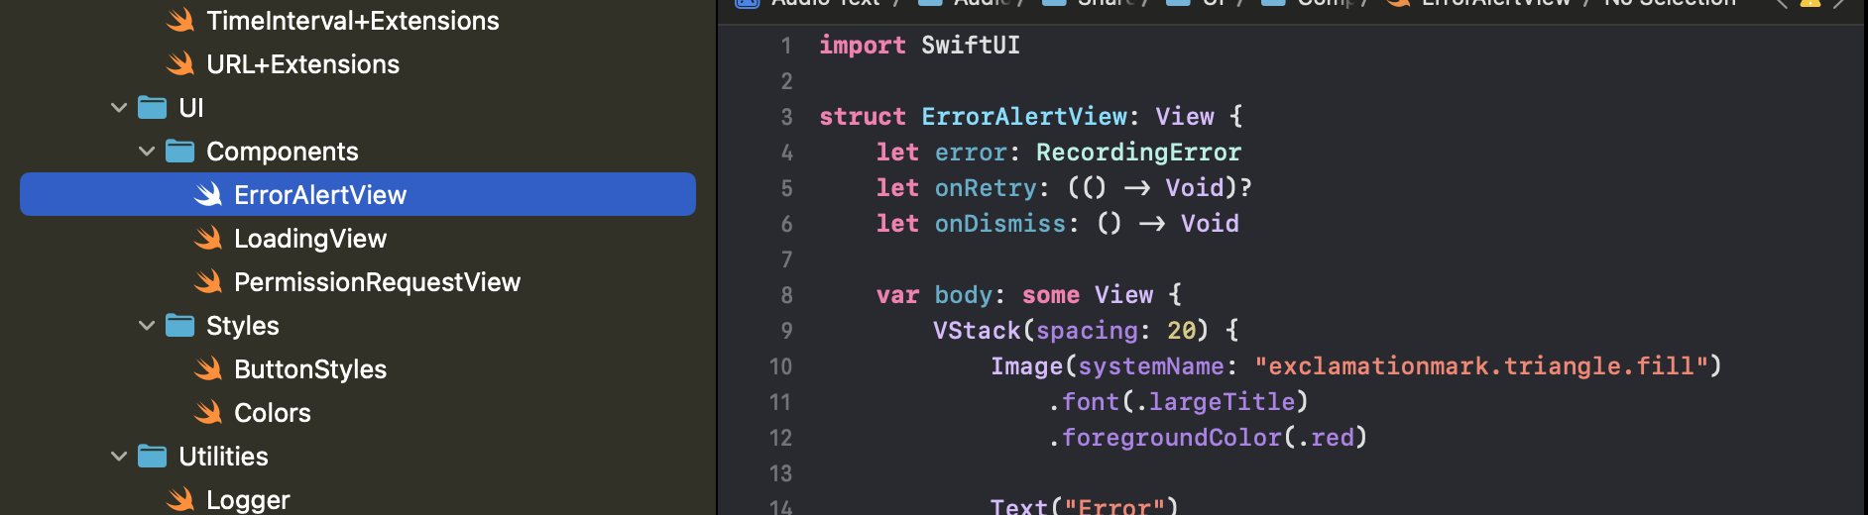

Audio System Design

Multi-Format Recording Strategy
The audio recording system implements a sophisticated fallback mechanism designed to maximize compatibility across different iOS devices and audio configurations. The primary approach attempts to record using the user's preferred quality settings, but automatically degrades to more compatible formats when hardware limitations or system constraints are encountered.
The recording pipeline begins by querying the device's audio capabilities and attempting to establish an optimal recording configuration. When the preferred format fails, the system progressively tries more conservative settings, ultimately falling back to the device's native input format. This ensures that recording can proceed regardless of hardware variations while maximizing quality when possible.
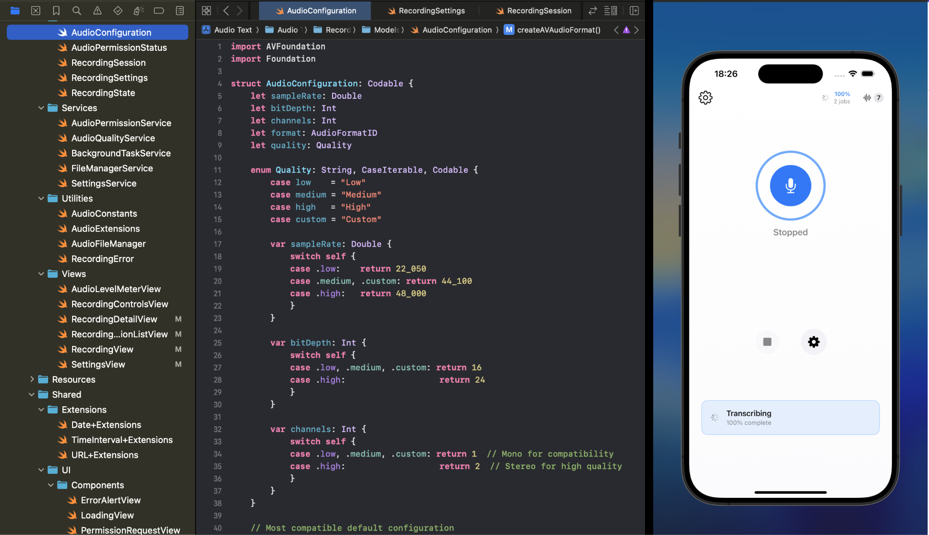

Audio Engine and Format Management
The core audio engine utilizes AVAudioEngine with carefully managed audio taps and format converters. The design prioritizes direct format compatibility to minimize computational overhead during recording. When format conversion is necessary, the system employs robust buffer capacity calculations that account for sample rate differences, channel variations, and internal converter requirements.
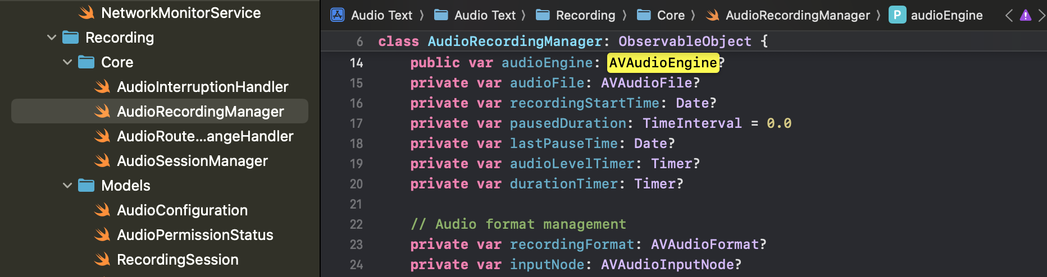
Format conversion operations include comprehensive error handling with automatic buffer recreation when capacity mismatches occur. The system monitors conversion success rates and adjusts buffer allocation strategies dynamically to prevent audio dropouts during extended recording sessions.

Route Change and Interruption Handling
Audio route changes represent one of the most challenging aspects of iOS audio development. The application monitors route changes through dedicated observers that react to device connections, disconnections, and audio session interruptions. When route changes occur, the system evaluates whether the current recording session can continue or requires reconfiguration.
The interruption handling system distinguishes between temporary interruptions (such as phone calls) and permanent route changes (such as headphone disconnection). Temporary interruptions pause recording and attempt automatic resumption when the interruption ends. Permanent changes trigger user notifications and may require manual intervention to restart recording with appropriate settings.
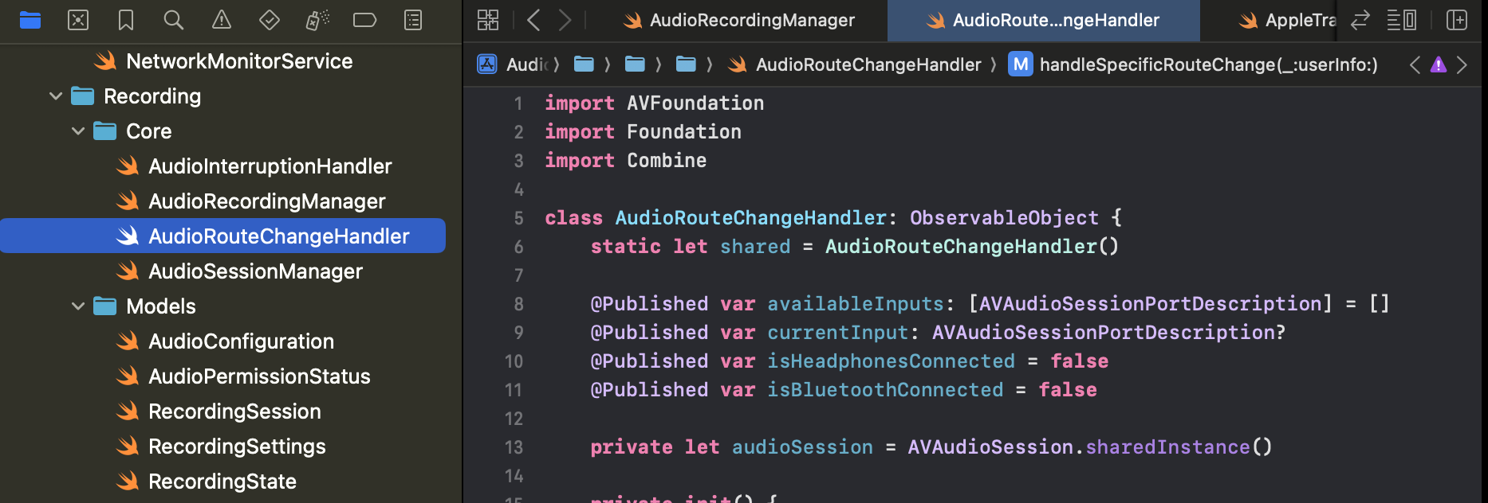

Background Recording Architecture
Background recording capabilities are implemented through a combination of background task management and audio session configuration. The system requests extended background execution time when recording begins and monitors remaining time to provide user warnings before forced termination.
The background audio architecture maintains recording quality while minimizing battery consumption through intelligent audio processing throttling. Non-essential audio analysis features are disabled during background operation, while core recording functionality remains at full fidelity.

Real-Time Audio Processing
The audio processing pipeline operates in real-time to support live transcription features. Audio buffers are processed in chunks small enough to maintain responsive UI updates while large enough to provide meaningful transcription segments. The system balances processing frequency with computational efficiency to maintain smooth operation during extended recording sessions.
Audio level monitoring employs efficient peak detection algorithms that provide visual feedback without impacting recording performance. The level calculation system uses optimized mathematical operations and strategic sampling to minimize CPU usage while maintaining responsive meter updates.
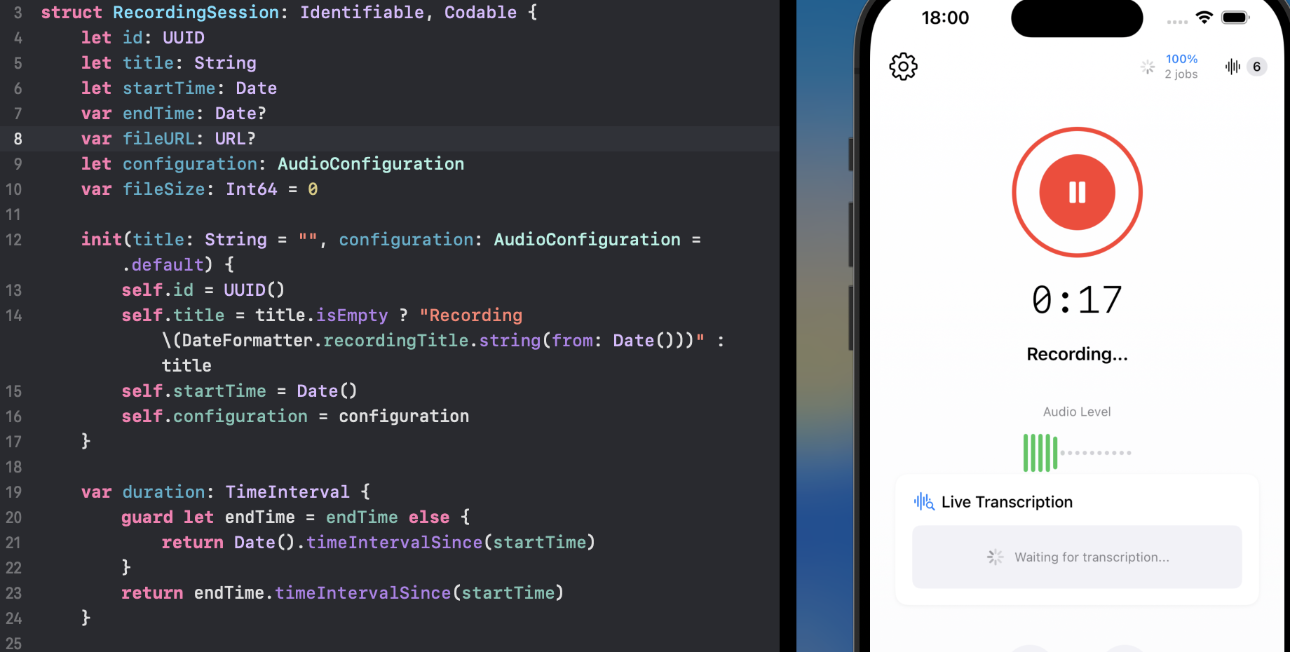

Data Model Design

Hierarchical Data Architecture
The data model employs a hierarchical structure that reflects the natural relationship between recording sessions, audio segments, and transcription jobs. At the top level, RecordingSession objects encapsulate complete recording episodes with associated metadata, configuration settings, and file references. Each session can spawn multiple TranscriptionSegment objects that represent processable audio chunks, while TranscriptionJob objects coordinate the overall transcription workflow.
This hierarchical approach enables efficient querying and relationship management while supporting the asynchronous nature of transcription processing. The model accommodates scenarios where transcription occurs long after recording completion, maintaining referential integrity across extended time periods.

Performance Optimization Strategies
Data persistence leverages SwiftData's native optimization capabilities while implementing additional performance enhancements tailored to audio processing workflows. Large audio files are referenced through URL-based storage rather than direct data embedding, preventing memory pressure during database operations. Transcription text storage employs intelligent chunking strategies that balance query performance with storage efficiency.
Index optimization focuses on the most common access patterns: chronological session retrieval, transcription status queries, and file size calculations. The indexing strategy supports efficient filtering and sorting operations while minimizing storage overhead for large recording collections.

Concurrency and Thread Safety
The data model implements comprehensive thread safety through strategic use of actor isolation and synchronization primitives. Database operations are confined to specific queues that prevent concurrent modification conflicts while allowing multiple read operations to proceed simultaneously. This approach ensures data integrity during complex operations like simultaneous recording and transcription processing.
State synchronization between the data layer and UI components utilizes MainActor isolation for presentation updates while allowing background processing to continue uninterrupted. This threading model maintains responsive UI performance even during intensive transcription operations.

File System Integration
Audio file management integrates closely with the data model through a sophisticated file lifecycle system. Audio files progress through multiple stages: temporary storage during recording, validation and format verification, and final archival storage. The data model tracks this progression and maintains referential integrity even when files are moved or renamed during processing.
File cleanup and maintenance operations are coordinated with data model updates to prevent orphaned files or broken references. The system includes comprehensive validation routines that verify file existence and integrity, providing automatic repair capabilities when possible.

Transcription Data Management
Transcription data storage accommodates the incremental nature of AI-powered text generation while optimizing for both storage efficiency and query performance. Individual segment transcriptions are stored with timing metadata and confidence scores, enabling sophisticated analysis and editing capabilities.
The transcription storage system supports multiple concurrent transcription attempts for the same audio content, allowing comparison between different AI services and enabling fallback scenarios when primary services fail. Version management ensures that users can access historical transcription attempts while maintaining clear indicators of the most current and accurate results.


Known Issues and Limitations

Audio Format Compatibility Challenges
The current audio recording system, while robust in its fallback mechanisms, occasionally encounters edge cases with specific iOS device configurations that result in suboptimal recording quality. Certain older iPad models exhibit inconsistent behavior when switching between high-quality recording formats and system-native formats, sometimes producing audio files with unexpected characteristics that impact transcription accuracy.
The format conversion pipeline, despite comprehensive buffer management, occasionally struggles with very long recording sessions on devices with limited memory. This manifests as temporary audio dropouts or processing delays when the system attempts aggressive format conversions during extended recordings. While these issues rarely result in data loss, they can impact the user experience during critical recording sessions.

Transcription Service Dependencies
The application's reliance on external transcription services introduces inherent limitations regarding offline functionality and processing consistency. Network connectivity requirements for OpenAI Whisper integration create scenarios where high-quality transcription becomes unavailable precisely when users need it most. While Apple's on-device speech recognition provides a fallback option, the quality disparity between services can be significant for technical content or speakers with non-standard accents.
API rate limiting and service availability fluctuations occasionally result in transcription delays that extend far beyond user expectations. The current retry mechanism, while comprehensive, cannot fully compensate for extended service outages or quota limitations that may affect users during high-volume periods.

Memory Management During Concurrent Operations
Complex scenarios involving simultaneous recording, real-time transcription, and background processing can strain memory resources on older iOS devices. The application implements sophisticated memory management techniques, but certain combinations of high-quality recording, multiple concurrent transcription jobs, and extensive audio file collections can approach system memory limits.
The segmented transcription approach, while enabling real-time processing, creates numerous temporary files that require careful lifecycle management. In scenarios with interrupted transcription processes, temporary file cleanup may not execute completely, leading to gradual storage consumption that users may not immediately notice.

User Interface Responsiveness
During intensive audio processing operations, the user interface occasionally exhibits minor responsiveness delays, particularly when displaying complex transcription progress information while maintaining real-time audio level meters. These delays are typically brief and don't impact core functionality, but they can create a perception of reduced application performance during critical recording moments.
The notification and alert system, while comprehensive, can sometimes overwhelm users with status updates during complex transcription workflows involving multiple concurrent jobs. Balancing informative feedback with user interface clarity remains an ongoing challenge, particularly for users managing large recording collections.

Data Synchronization Edge Cases
Certain edge cases in data synchronization can occur when users rapidly start and stop recording sessions while background transcription processes are ongoing. While the application includes safeguards against data corruption, these scenarios can occasionally result in transcription jobs that become disconnected from their source recordings or segments that fail to properly associate with their parent sessions.
The file system integration, despite robust error handling, can encounter issues when iOS storage management systems automatically relocate or compress audio files without application notification. These system-level operations can temporarily break file references until the application's validation routines detect and repair the inconsistencies.

Performance Optimization Opportunities
The current implementation prioritizes functionality and reliability over maximum performance optimization. Several areas present opportunities for enhancement, including more aggressive audio compression algorithms, improved caching strategies for frequently accessed transcription data, and enhanced background processing coordination that could reduce overall system resource consumption.
Battery usage optimization represents another area for future development, particularly regarding background transcription operations that continue processing while users interact with other applications. While current power management is adequate, more sophisticated algorithms could extend device battery life during extended transcription workflows without significantly impacting processing speed or quality.

Performance Optimization Opportunities

Below are screenshots of the application.

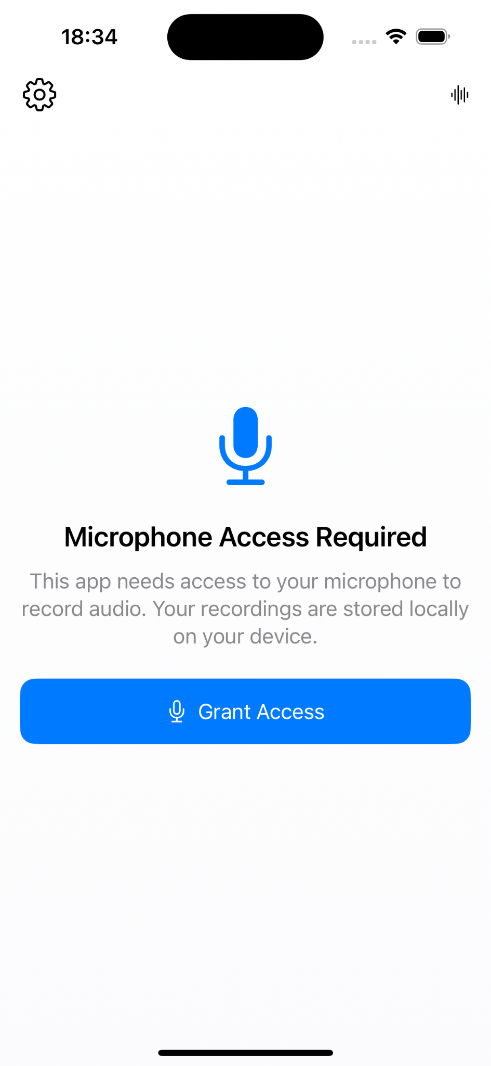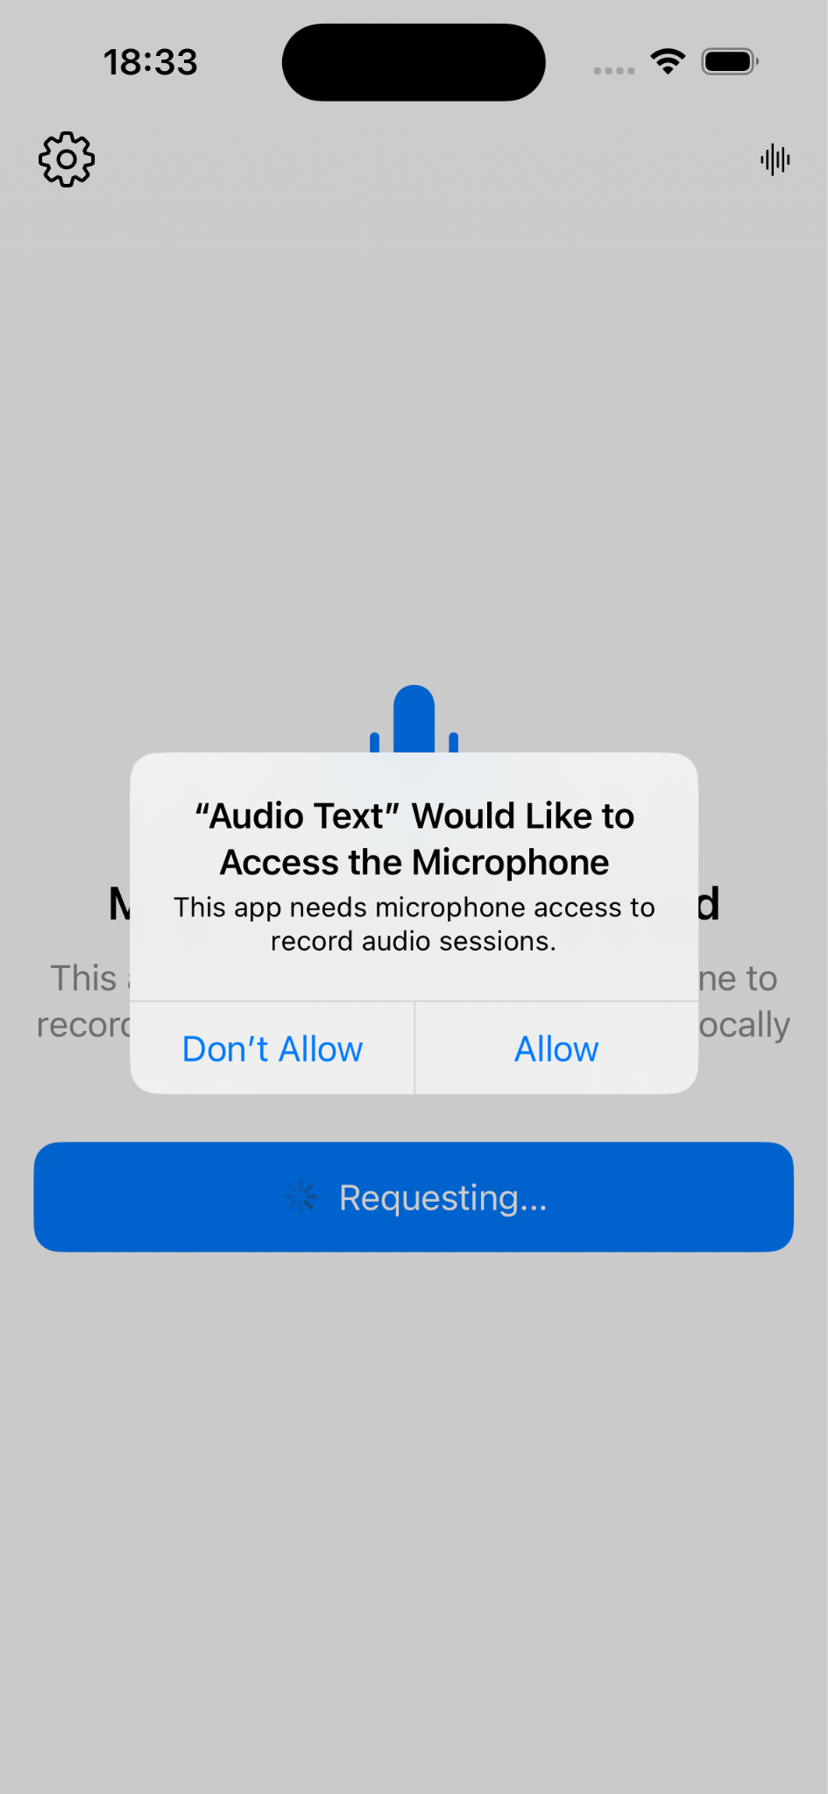
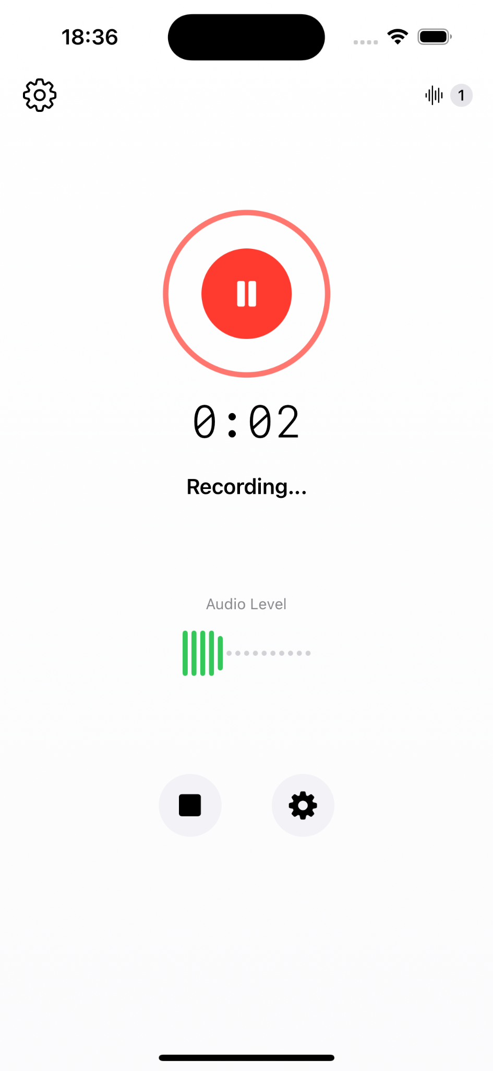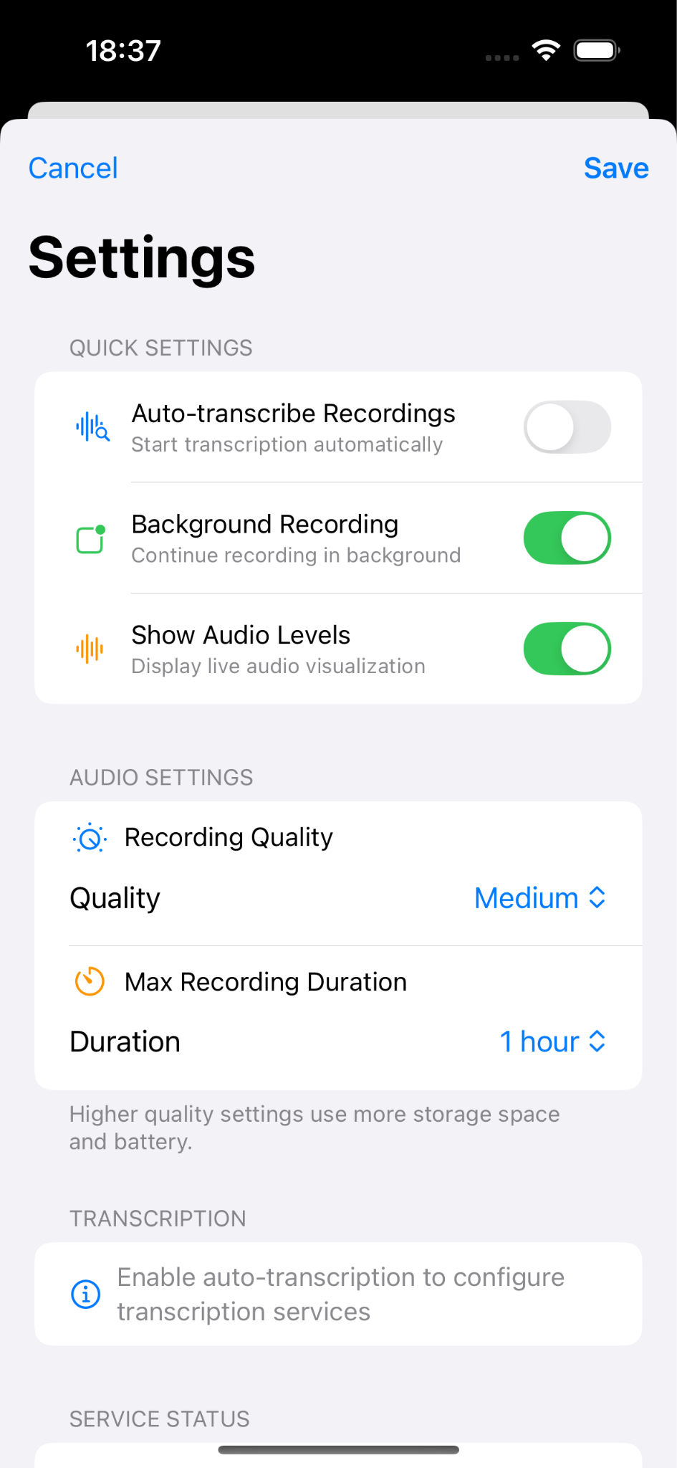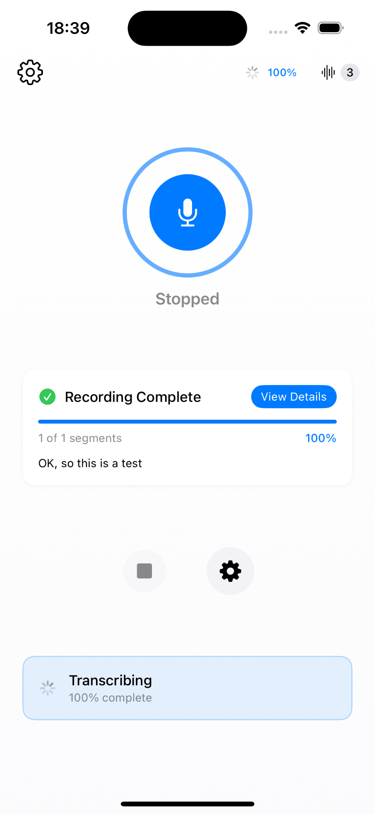
Testing
The Audio-Text application includes a comprehensive suite of automated tests designed to validate its core functionality and architectural components. Unit tests cover critical business logic, including audio session management and transcription data models, ensuring that recording workflows and data storage remain reliable across updates. Integration tests verify seamless coordination between the audio system and transcription services, simulating real-world interactions with external AI APIs. Edge case tests rigorously exercise the app’s error handling strategies, validating retry mechanisms and service fallback behavior under failure conditions. Performance tests evaluate the system’s ability to process large audio datasets efficiently, reflecting real-world usage scenarios involving extended recording sessions. Together, these tests help maintain a robust, maintainable, and high-quality codebase aligned with the app’s MVVM and service-layer architecture.
